**MINUTES**

**Windermere Tree Board**

**July 18, 2024**

Mission Statement: Augment community awareness of our Urban Forest, provide education regarding the benefits of trees and a commitment to protect, preserve and proliferate our community’s Urban Forest. Beautify our Windermere Parks and Recreation Areas.

Tree Board Members: Frank Krens, Pamela Schrimsher, Vicki Hearst, Bonnie DiCocco, Joan Foglia, Elena LaRochelle, Olga Aleksandrova

### THE MEETING IS CALLED TO ORDER

Tree Board member Frank Krens called the meeting to order at 9:19am in the Windermere Town Hall at 520 Main Street, Windermere, FL 34786. The requirement for a quorum was met.

Participants:

* + **Tree Board** – Frank Krens, Pamela Schrimsher, Vicki Hearst, Olga Aleksandrova, Bonnie DiCocco joined via Zoom.
  + **TOW Public Works** – Tonya Elliott-Moore
  + **Town Council** – Brandi Haines

1. **OPEN FORUM / PUBLIC COMMENT (3-Minutes Limit)**
   1. **No public comment**

### MINUTES

* 1. **June 20, 2024**
     + After discussion regarding the number of trees for the Centennial Celebration and giveaway, it was decided to leave the minutes as they stand. Olga made a motion to approve the minutes. Vicki seconded the motion. Motion carried.

### OFFICER / COMMITTEE REPORTS AND ADMINSTRATIVE MATTERS

* 1. **Financial Report (Pam Schrimsher)**
     + May and June produced no debits or credits to the reports. Pam is to provide the reports to Tonya.
  2. **Budget Planning Process**
     + Budget planning to begin in December and proceed through February to allow for the efforts necessary to execute the Tree Giveaway in January. In March, a draft budget should be submitted per Tonya’s advice.
  3. **Other Reports**
     + No other reports were submitted.

### OLD BUSINESS

* 1. **Status of 500 Block Mitigation Plantings**
     + Jennifer Hitchcock of Orlando Tree Consulting evaluated the tree trimming and is ok with the methods and progress. John and Tonya will schedule for Jennifer to return after the final pruning.
  2. **Bylaws Updated for Officers Signing**
     + Frank is following up on the bylaw updates.
  3. **Manual Updating of the Tree Survey for Town Square**
     + This will be a tedious and ongoing process to update the inaccurate tree varieties in the tree survey.
  4. **Completion of the Historic Grove Removals and Replants**
     + Frank noted that the grove was pruned by Orlando Tree Consulting and looks great. The dead wood and declining trees were removed (July 13, 2024) and the new trees planted. Irrigation is being adjusted today, July 18, 2024.
  5. **500 Block Update**
     + See notes above.
  6. **Arborist Convention Summary**
     + Pam and Vicki will be submitting their convention notes to Tonya for the group to review.

### NEW BUSINESS

* 1. **Deep-Dive into the Strategic Plan and Implementation**
     + The Board discussed, at the suggestion of Tonya, presenting the Strategic Plan to Town Council at their August 13 meeting or soon thereafter.
  2. **Historic Tree Walk Document**
     + This conversation was deferred until a later date.
  3. **Refining and Implementing the Centennial Celebration Tree Planting Program**
     + The Board discussed a November event, in conjunction with UF’s IFAS extension, to allow residents to pick up an application for the Legacy Tree program which will be implemented at the Centennial Celebration.
     + A copy of the application is provided in the minutes.  
       - A few modifications to the application should be made as follows:  
         * Treese do NOT have to be accessible to the public, just visible.
         * The use of a hose should be changed to note possible hand watering
     + The Centennial Committee also provided a sample of the plaque that is to be installed with each Legacy Tree.
     + Vicki will provide the final alterations to the document for Tonya’s review prior to the next meeting.
  4. **Potential Change to Guidelines to Accommodate Times with Members Who Cannot Regularly Attend Meetings**
     + It was discussed that a member, per the guidelines, cannot miss more than 3 meeting per year.
     + Members unable to attend can submit notes to Tony and the group can discuss in their absence.

1. **POTENTIAL AGENDA ITEMS FOR NEXT MEETING**
2. **DATE AND TIME FOR AUGUST MEETING**
   1. August 15, 2024 at 9:15am.
3. **ADJOURN –** Meeting was adjourned at 10:43am.

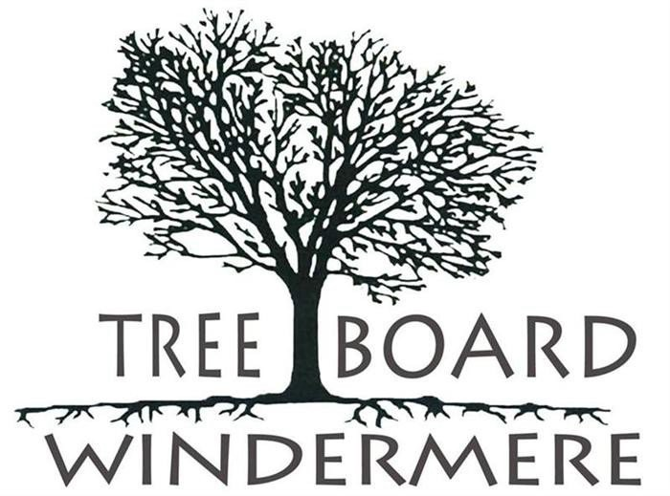

**WINDERMERE TREE BOARD**

**Chair: Frank Krens Vice Chair: Vicki Hearst**

**Secretary: Bonnie Di Cocco Treasurer: Pamela Schrimsher Joan Foglia**

**Olga Aleksandrova Elena LaRochelle**

**Council Liaison: Brandi Haines**

**June 20, 2024**

**9:15 AM**

**COMMUNITY CONFERENCE ROOM 614 MAIN STREET, BUILDING 100**

**WINDERMERE, FL 34786**

## DRAFT MINUTES

### THE MEETING IS CALLED TO ORDER BY THE CHAIR

Chairman Frank Krens called the meeting to order with a quorum at 9:35am. Participants: Frank Krens, Vicki Hearst, Elena LaRochelle, Olga Aleksandrova Public Works: Tonya Elliott-Moore

Town Resident and Centennial Celebration Chair: CT Allen

1. **OPEN FORUM / PUBLIC COMMENT (3-Minutes Limit) - none**

### MINUTES

* 1. Vicki made a motion to approve the May minutes. Olga seconded. Motion carried.

### OFFICER / COMMITTEE REPORTS AND ADMINISTRATIVE MATTERS

* 1. **Financial Report (Pam Schrimsher) - Pam was not in attendance to present her report.**
  2. **Budget Planning Process - deferred**
  3. **Other Reports – Centennial Celebration Participation by Tree Board**

Centennial Celebration Chair CT Allen offered ideas and funding to promote and support Tree Board’s participation in the celebration aside from and in addition to the annual tree giveaway, which will also be tailored by Tree Board to support the Centennial Celebration.

CT said the Wine & Dine organization would dedicate $5000 to purchase 100 large variety type “Legacy” trees, with 50 to be planted on Town property and 50 to be planted by Town residents on their private property. Each Legacy Tree would be accompanied by a metal stake with an attractive and durable commemorative plaque. At Vicki’s recommendation, CT agreed to increase the contribute to $6000 for the project and consider designating 40 trees to be planted on Town property and 60 to be planted on residential properties.

Residents wanting to receive, plant, and dutifully maintain a Legacy tree would submit an application wherein they agree to plant the tree in a suitable location (consistent with right tree right place guidance), visible from the street and to water and care for the tree. Once the tree has been appropriately planted, the resident would receive their metal stake with the commemorative plaque to positioned securely in front of the tree and maintained long-term.

Tree Board would be responsible for selecting the trees, choosing potting sizes, advertising and promoting the program, generating and distributing the application forms, selecting applicants to receive the Legacy trees, approval of planting locations, assisting the recipients of the trees with educational materials including a class and also planting support when needed, publicity via Town website, social media, Windermere Gazette and/or other means, and keeping records including a map of the Legacy Tree locations.

Olga offered to draft an application form.

**Elana made a motion for Tree Board to move forward to implement a plan to plant 100 Legacy trees. Olga seconded and the motion carried 4/0.**

### OLD BUSINESS

* 1. **500 Block Tree Mitigation Planting Approved List Update – Plans and Status**

This is proceeding as planned. Vicki stated that the list is complete. Tonya stated that she is getting quotes.

* 1. **Unadopted Tree Plan and Status Update (Vicki Hearst)**

Unchanged since last meeting – 3 little trees remain to be planted, Vicki will rehabilitate 2 figs for next year’s giveaway.

* 1. **Bylaws Update Provided by Town Manager**

Tonya said she would get a copy for WTB officer signature from Town Manager Robert Smith.

* 1. **Tree Survey Update on Tree Variety ID and How to Add New Trees**

Tonya stated that ownership of the survey product/service has changed hands, is now owned by Davey Tree Service, and that we are probably better off making best use of the asset in the form that we have rather than trying to have lacking features corrected by Davey. While there are shortcomings such as the incorrect identification of tree variety, the product is useful as is and we can manually update and revise it.

As a starting point she recommended that we manually update the model for trees on the Town Square.

* 1. **Historic Grove Update on the 15 Citrus and 2 Mangos Ordered (Tonya Elliott- Moore)**

Tonya stated that tree removal and replant is scheduled for June 26, 2024.

* 1. **500 Block Update - deferred**
  2. **Board Education Events Completed / New Opportunities**

Pam and Vicki will summarize their learning from the Arborist Convention they attended and present it at a future meeting.

### NEW BUSINESS

* 1. **Strategic Plan – Deep-dive into the Plan and Implementation**
     1. **Regulatory Update Approach**

Tonya stated that we will need Town Planner Brad Cornelius to lead us in this. It will involve review of the Town’s Tree Ordnance, the approved planting list, a search of relevant items in the municode, and judicious adjustment of penalties to raise them whil ensureing reasonableness.

* + 1. **Other Near-Term Plans / Actions - Deferred**

### POTENTIAL AGENDA ITEMS FOR NEXT MEETING

* 1. Deep-dive into the Strategic Plan and implementation
  2. Historic Tree Walk document (part of the Heritage Tree program)
  3. Refining and Implementing the Centennial Celebration Tree Planting Program.
  4. Potential Change to Guidelines to Accommodate Times with Members Cannot Regularly Attend Meetings

1. **DATE AND TIME FOR JULY MEETING – 07/18/2024, 9:15am**.
2. **ADJOURN –** Meeting was adjourned at 11:54am