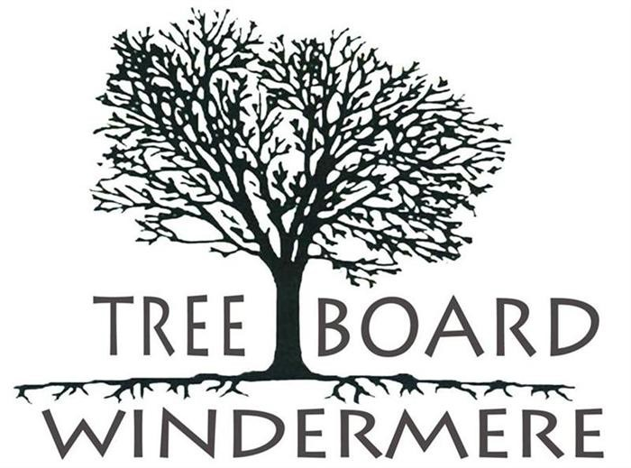

**WINDERMERE TREE BOARD**

**Chair: Frank Krens Vice Chair: Vicki Hearst**

**Secretary: Bonnie Di Cocco Treasurer: Pamela Schrimsher Joan Foglia**

**Olga Aleksandrova Elena LaRochelle**

**Council Liaison: Brandi Haines**

**June 20, 2024**

**9:15 AM**

**COMMUNITY CONFERENCE ROOM 614 MAIN STREET, BUILDING 100**

**WINDERMERE, FL 34786**

**DRAFT MINUTES**

### THE MEETING IS CALLED TO ORDER BY THE CHAIR

### Chairman Frank Krens called the meeting to order with a quorum at 9:35am.

### Participants: Frank Krens, Vicki Hearst, Elena LaRochelle, Olga Aleksandrova

### Public Works: Tonya Elliott-Moore

### Town Resident and Centennial Celebration Chair: CT Allen

1. **OPEN FORUM / PUBLIC COMMENT (3-Minutes Limit) - none**

### MINUTES

* 1. Vicki made a motion to approve the May minutes. Olga seconded. Motion carried.

1. **Officer / Committee Reports and Administrative Matters**
   1. **Financial Report (Pam Schrimsher) - Pam was not in attendance to present her report.**
   2. **Budget Planning Process - deferred**
   3. **Other Reports – Centennial Celebration Participation by Tree Board**

Centennial Celebration Chair CT Allen offered ideas and funding to promote and support Tree Board’s participation in the celebration aside from and in addition to the annual tree giveaway, which will also be tailored by Tree Board to support the Centennial Celebration.

CT said the Wine & Dine organization would dedicate $5000 to purchase 100 large variety type “Legacy” trees, with 50 to be planted on Town property and 50 to be planted by Town residents on their private property. Each Legacy Tree would be accompanied by a metal stake with an attractive and durable commemorative plaque. At Vicki’s recommendation, CT agreed to increase the contribute to $6000 for the project and consider designating 40 trees to be planted on Town property and 60 to be planted on residential properties.

Residents wanting to receive, plant, and dutifully maintain a Legacy tree would submit an application wherein they agree to plant the tree in a suitable location (consistent with right tree right place guidance), visible from the street and to water and care for the tree. Once the tree has been appropriately planted, the resident would receive their metal stake with the commemorative plaque to positioned securely in front of the tree and maintained long-term.

Tree Board would be responsible for selecting the trees, choosing potting sizes, advertising and promoting the program, generating and distributing the application forms, selecting applicants to receive the Legacy trees, approval of planting locations, assisting the recipients of the trees with educational materials including a class and also planting support when needed, publicity via Town website, social media, Windermere Gazette and/or other means, and keeping records including a map of the Legacy Tree locations.

Olga offered to draft an application form.

**Elana made a motion for Tree Board to move forward to implement a plan to plant 100 Legacy trees. Olga seconded and the motion carried 4/0.**

### OLD BUSINESS

* 1. **500 Block Tree Mitigation Planting Approved List Update – Plans and Status**

This is proceeding as planned. Vicki stated that the list is complete. Tonya stated that she is getting quotes.

* 1. **Unadopted Tree Plan and Status Update (Vicki Hearst)**

Unchanged since last meeting – 3 little trees remain to be planted, Vicki will rehabilitate 2 figs for next year’s giveaway.

* 1. **Bylaws Update Provided by Town Manager**

Tonya said she would get a copy for WTB officer signature from Town Manager Robert Smith.

* 1. **Tree Survey Update on Tree Variety ID and How to Add New Trees**

Tonya stated that ownership of the survey product/service has changed hands, is now owned by Davey Tree Service, and that we are probably better off making best use of the asset in the form that we have rather than trying to have lacking features corrected by Davey. While there are shortcomings such as the incorrect identification of tree variety, the product is useful as is and we can manually update and revise it. As a starting point she recommended that we manually update the model for trees on the Town Square.

* 1. **Historic Grove Update on the 15 Citrus and 2 Mangos Ordered (Tonya Elliott-Moore)**

Tonya stated that tree removal and replant is scheduled for June 26, 2024.

* 1. **500 Block Update - deferred**
  2. **Board Education Events Completed / New Opportunities**

Pam and Vicki will summarize their learning from the Arborist Convention they attended and present it at a future meeting.

1. **NEW BUSINESS**
   1. **Strategic Plan – Deep-dive into the Plan and Implementation**
2. **Regulatory Update Approach**

Tonya stated that we will need Town Planner Brad Cornelius to lead us in this. It will involve review of the Town’s Tree Ordnance, the approved planting list, a search of relevant items in the municode, and judicious adjustment of penalties to raise them whil ensureing reasonableness.

1. **Other Near-Term Plans / Actions - Deferred**
2. **POTENTIAL AGENDA ITEMS FOR NEXT MEETING**
   1. Deep-dive into the Strategic Plan and implementation
   2. Historic Tree Walk document (part of the Heritage Tree program)
   3. Refining and Implementing the Centennial Celebration Tree Planting Program.
   4. Potential Change to Guidelines to Accommodate Times with Members Cannot Regularly Attend Meetings
3. **DATE AND TIME FOR JULY MEETING – 07/18/2024, 9:15am**.
4. **ADJOURN –** Meeting was adjourned at 11:54am