Historic Preservation Board
Meeting Minutes • 5:00 pm Thursday, April 06, 2023

614 Main Street Windermere, FL 34786
Call to order: 5:02: Kimberly Head Motioned Jangi Borhi second by Donna Steele
Attendees included:
Kim Hawkins-Head, Mary Fran Howard, Jangi Borhi, Liz Andert, Donna Steele
Guest: Frank Krens • Town Staff Liason: Public Works Travis Mathias
Members not in attendance included Joan Foglia and Hannah Ammar, Town Council Liasson absent
Approval of minutes: Jangi Borhi seconnd by Donna Steele second • Members approved

UNFINISHED BUSINESS
FACILITIES
• Inspection List: Liz Andert will research and provide best solution
NEW BUSINESS
• Welcomed new board members: L. Andert + D. Steele
• Board positions for 2023 (needed): Secretary (D. Steele is considering)
• Discussed Keynote speaker ideas
• Ideas for 2023 on how to build awareness of the Town of Windermere’s history: Cal Palmer Days, Book Club: NEVER AGITATE AN ALLIGATOR: Boyhood Adventures in Florida , School house tours
• Donating Bench in honor of: Jacqueline (Jackie) Rapport to not exceed $2000.00. Motion by K. Hawkins-Head and all approved. (K. Head will coordinate with Garden Club V. Hearst)
• Sergie Merkelov, guest speaker presented medal detection of town hall. Board voted approval for him to talk to Town Manager R. Smith for next step.

Adjournment: 6:08 pm / Kimberly Head Motioned by Jangi Borhi seconnd by Donna Steele
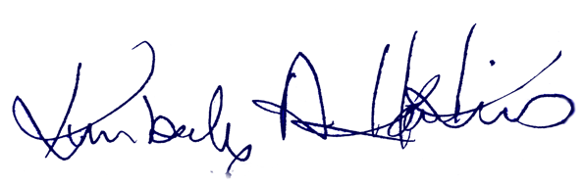
Historic Preservation Board Chair |  | Date of approval

