Historic Preservation Board
Meeting Minutes • 4:30 Wed, March 01, 2023

614 Main Street Windermere, FL 34786
Call to order: 4:35: Kimberly Head Motioned by Joan Foglia second by Hannah Ammar, Mary Fran Howard
Attendees included:
Hannah Ammar, Joan Foglia, Kim Hawkins-Head, Mary Fran Howard
Members not in attendance included Jangi Borhi
Approval of minutes: Hannah Ammar second by Joan Foglia second • Members approved

UNFINISHED BUSINESS
FACILITIES
• Inspection List:
• Immediate maintenance
NEW BUSINESS
• Town Hall Repair has been awarded to Tom Price Architects
• The town’s 100 year birthday celebration planning will begin in 2023.
• Suggestions for board Secretary – (search is current)
• New Members: Liz Andert and Donna Steele. (Kimberly Head Motioned by Joan Foglia second by Hannah Ammar)
- Discussed new (protentional) band shell. Board voted to not provide town council a formal opinion from HPB.
- Board accepted Tom Stroup’s resignation.
- Tom Stroup will be new town council liaison
- NEW MEETING TIME! First Thursdays at 5pm
- Discussed new member ideas
- Discussed ideas to honor Jackie Rapport

Adjournment: 5:37 pm / Kimberly Head Motioned by Joan Foglia second by Hannah Ammar
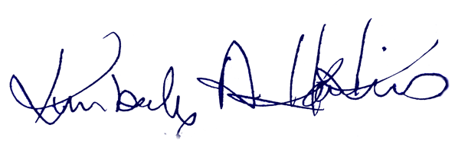
Historic Preservation Board Chair |  | Date of approval

