Historic Preservation Board
Meeting Minutes • 4:30 Wed, December 07, 2022
614 Main Street Windermere, FL 34786
Call to order: 4:37: Kimberly Head Motioned by Jangi Borhi second by Joan Foglia
Attendees included:
Hannah Ammar, Mary Francis Howard, Joan Foglia, Kim Hawkins-Head, Jangi Borhi,
Members not in attendance included Tom Stroup
Approval of minutes: Hannah Ammar second by Jangi Borhi second • Members approved

UNFINISHED BUSINESS
FACILITIES
• Inspection List: (NO report: om Stroup was absent)
• Immediate maintenance (NO report: om Stroup was absent)
• Financial report (balance confusion has been cleared up
FINANICAL
• ANNUAL BUDGET $44k per year. (discrepancy in Excel doc has been cleared up)

NEW BUSINESS
• Town Hall Repair has been awarded to Tom Price Architects
• The town’s 100 year birthday celebration planning will begin in 2023.
• Suggestions for board Secretary – (search is current)
• Palmer House:
- Pest Control; need person to sweep cobwebs off structure, note to town to see if this is a town maintenance task.
- Hole in floor needs to addressed
- Discussed new (potentional) band shell.

Adjournment: 5:37 pm / Kimberly Head Motioned by Jangi Borhi second by Hannah Ammar
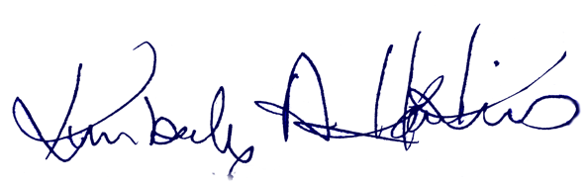
Historic Preservation Board Chair |  | Date of approval

