Minutes of Meeting DRAFT
Date: July 22, 2019 9:00 am
Location: Town Office – Public Works

Committee Present:
Stephen Withers, Secretary sewarch@hotmail.com 321-945-2501
Chris Sapp, Town Council csapp@town.windermere.fl.us 407-574-1002
Scott Brown, Director of Public Works sbrown@town.windermere.fl.us
On Conference Call:
John Fitzgibbon, Chair jpfds@cfl.rr.com 407-876-0129
Byron Sutton, Rotary Club of Windermere byronksutton@outlook.com
407-257-1806
Matthew Matin, DBC MattSellsOrlando@gmail.com 321-948-5857

Copy of Minutes to:
Robert Smith, Town Manager rsmith@town.windermere.fl.us 407-876-2563
Diane Edwards, Town admin. assistant dedwards@town.windermere.fl.us

Plans and perspective were received from HuntonBrady, Architects.
John Fitzgibbon presented the plans to the Committee.

The attached sketch addressed the comments made by the Committee however it is expected of the architects to review and insure the sizes meet codes etc.

Comments:
- Project seems much bigger than expected and extends into the road right of way. Scale needs to be brought down so the project is affordable.
- The project design presents everything elevated on a plinth 24” above grade. The Committee suggests that the concession stand and toilets would work much better at grade.
- The stage should be designed for 40 musicians. If necessary for cost some musicians could be placed on grade in front of the stage. Stage area look large.
- The Committee questioned if individual toilets require more area and cost than typical men’s and women’s restrooms rooms. One ADA / family restroom seems logical being unisex.
- The facility should not be air-conditioned therefore the size of the equipment room was questioned as being too big. The spaces should have fans to cool the areas and cross ventilation is important. The west wall needs to be a sound wall deflecting noise away from the house to the west but consideration for cross ventilation needs to also be addressed. Some equipment if required could be on a mezzanine over the toilets or concession stand as these spaces do not require the height of the stage.
- Much of the electrical controls need to be where the operator can see the stage.
- The concession stand size was also questioned and should be reduced. Some storage is needed but not what is shown.
- The building does not need storage for more than for a few instruments.
- Electrical and storage should not be in same room.
- The south end of the building does not need a large roof overhang but the north end overhang will be good for shading people queued up for the concession window. Therefore the roof might stay symmetrical but the building may have south wing longer.
- Ramps on the front north and south sides of the stage are preferred. See sketch as to how the plinth could be extended to accommodate two ramps.
- The truss over the front of the stage could be solid to hide lights and screen.
- It is expected that the movie night will be back projected onto a drop down screen. Screen could show sponsor adds to raise money.
- The Town Hall square should look compatible in design and materials.
- The architects need to provide a revised plan. When the committee approves the plan then a revised rendering can be done. The revised rendering needs to show trees and landscaping. Each side of the stage in front of the ramps could be heavily landscaped.

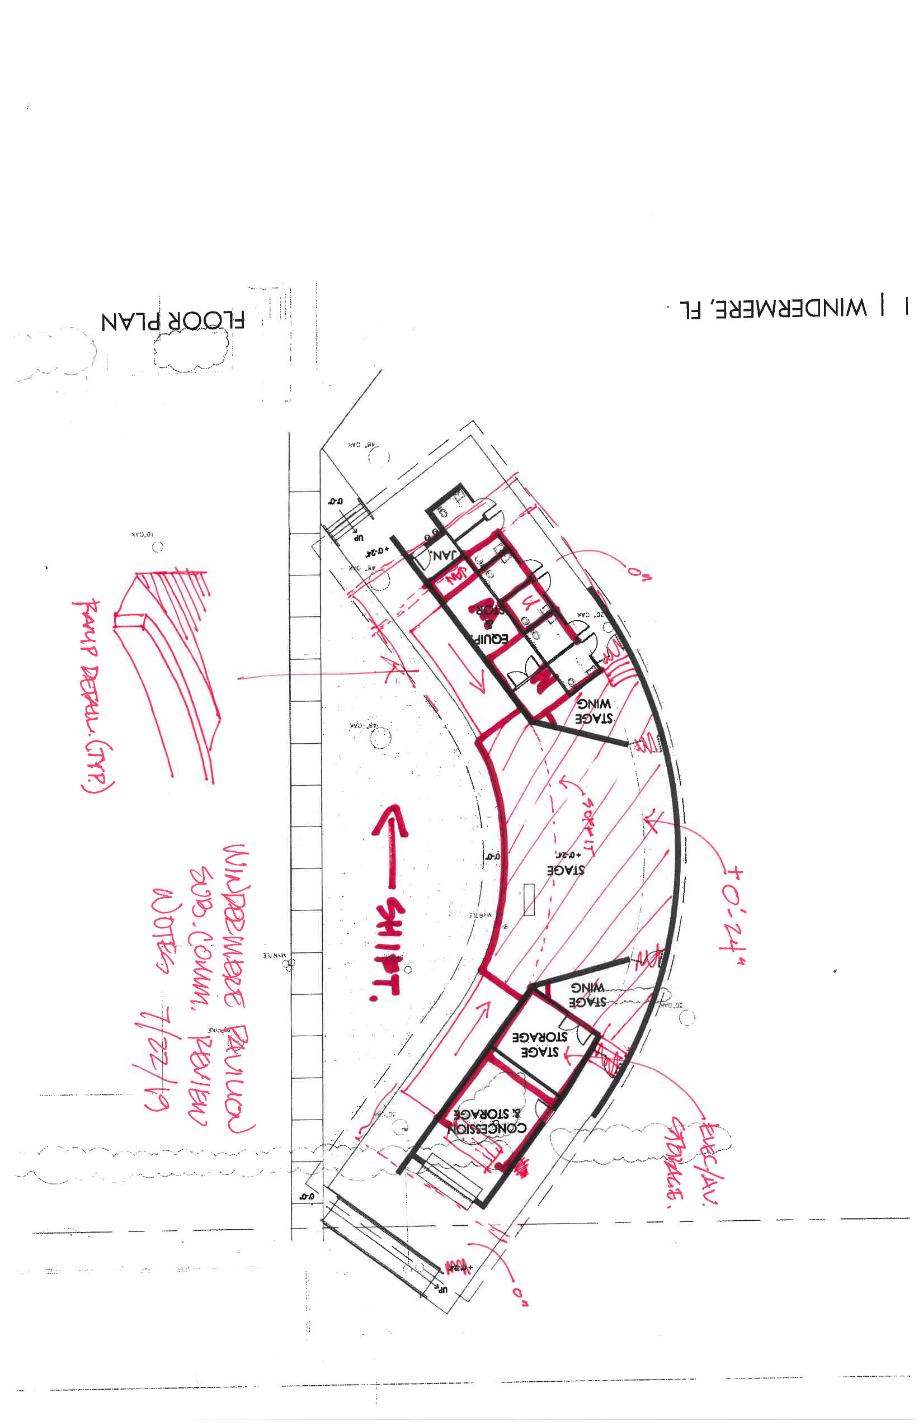
Minutes submitted by Stephen Withers

The attached program and schedule shall be attached to each set of minutes to ensure the Committee says focused on the goal and to modify the program as required as information is gathered.

Approved program and intent for an outdoor event pavilion:
- Functional “stage” space for events.
- Fits with the Town Masterplan for Town Hall site
- Replace existing “Community” Room’s toilets. (Community Building needs to be replaced,)
- Pavilion with three sides to project sound away from houses to west.
- Possible enclosed forth side.
- Concession stand to serve Town events.
- Storage to accompany building.
- This will be a capital improvement project but will rely on donated funds and not rely on Town public funds.
Schedule:
- March 21, 2019 Receive HB written Proposal
- March 21, 2019 Windermere Tree Board
- March 25, 2019 Rotary Meeting
- March 26, 2019 Town Council – agenda full.
- March 27, 2019 Historical Preservation Board
- March 28, 2019 Long Range Planning
- April 3, 2019 Downtown Business Committtee
- April 3, 2019 Due date for Town Council agenda items
- April 5, 2019 Rotary Meeting
- April 9, 2109 Town Council Meeting

